# Problem Title

1. **INTRODUCTION**
   1. **OVERVIEW**
   2. **PURPOSE**
2. **PROBLEM STATEMENT & DESIGN THINKING**
   1. **EMPATHY MAP**
   2. **IDEATION & BRAINSTORMING MAP**
3. **RESULT**

**a. SHEETS**

1. **DASHBOARD**
2. **STORY**
3. **ADVANTAGES & DISADVANTAGES**
4. **APPLICATION**
5. **FUTURE SCOPE**
6. **CONCLUSION**

# 

1. INTRODUCTION

Uber, in full Uber Technologies, Inc., American company that provides services related to mobility. The business's signature product is an application for smartphones that allows users to request transportation from drivers of privately owned vehicle.

1.1. OVERVIEW

We are a tech company that connects the physical and digital worlds to help make movement happen at the tap of a button. Because we believe in a world where movement should be accessible. So you can move and earn safely. In a way that's sustainable for our planet.

1.2. PURPOSE

Uber is a transportation company with an app that allows passengers to hail a ride and drivers to charge fares and get paid. More specifically, Uber is a ridesharing company that hires independent contractors as drive.

2.PROBLEM STATEMENT & DESIGN THINKING

Uber is facing numerous challenges, including competition, driver dissatisfaction, financial losses, and safety concerns, which may result in the loss of market share and customers if changes are not made. Uber uses an open-source ringpop to make the application cooperative and scalable for heavy traffic. Ring pop has mainly three parts and it performs the below operation to scale the dispatch system. It maintains consistent hashing to assign the work across the workers.

2.1. EMPATHY MAP

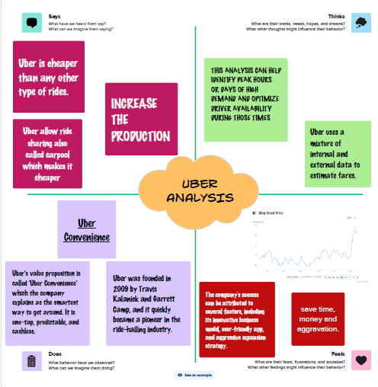

2.2. BRAINSTORMING MAP

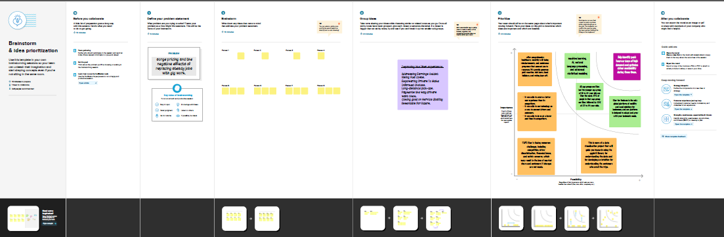

1. RESULT

3.1. MILES

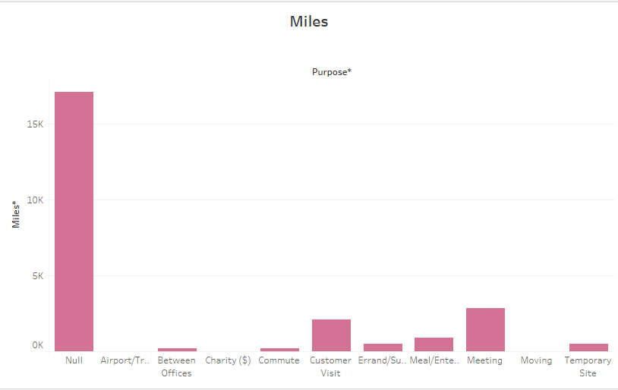

3.2 CATEGORY

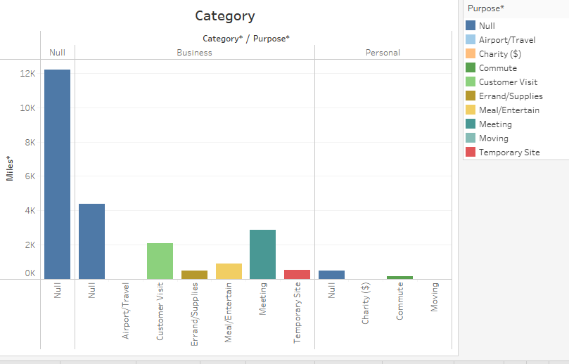

3.3. CATEGORY OF MILES

# C:\Users\HP\Downloads\O9.png

3.4 MONTH OF END

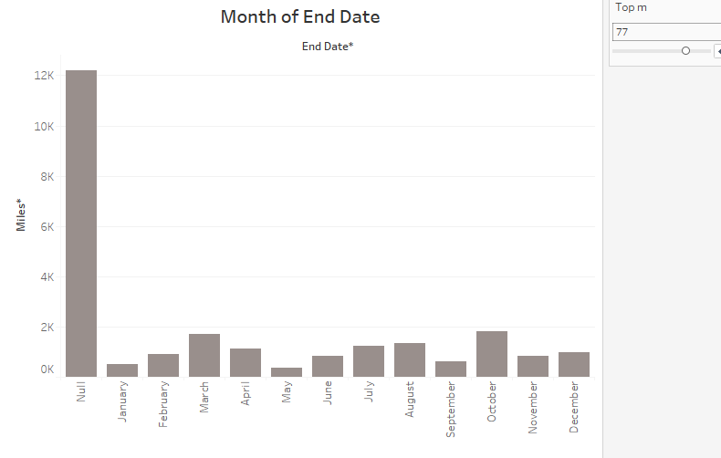

3.5 YEAR OF END DATE

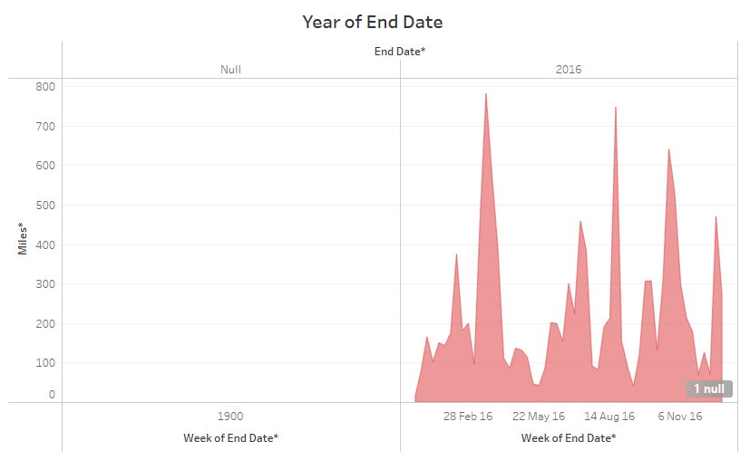

3.6. QUARTER OF MILES

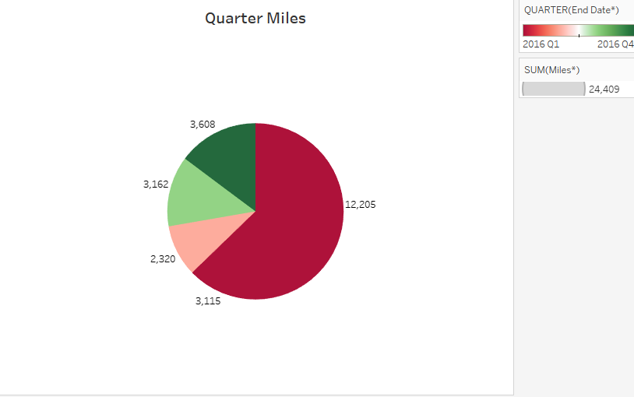

3.7. END DATE

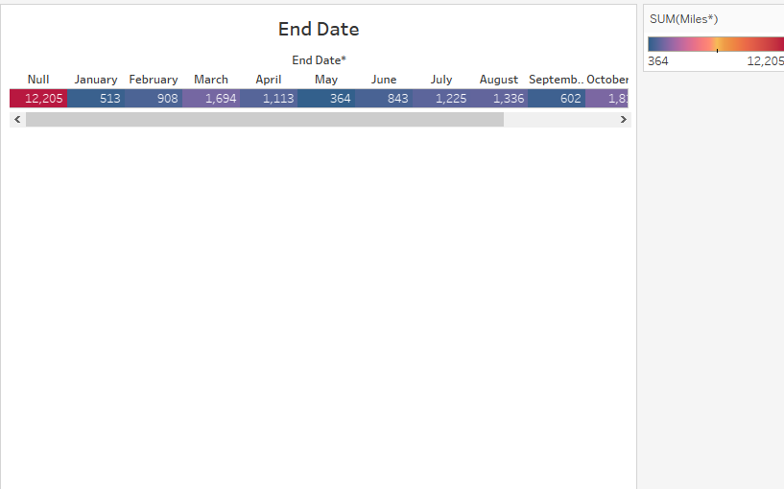

3.8. MILES END DATE

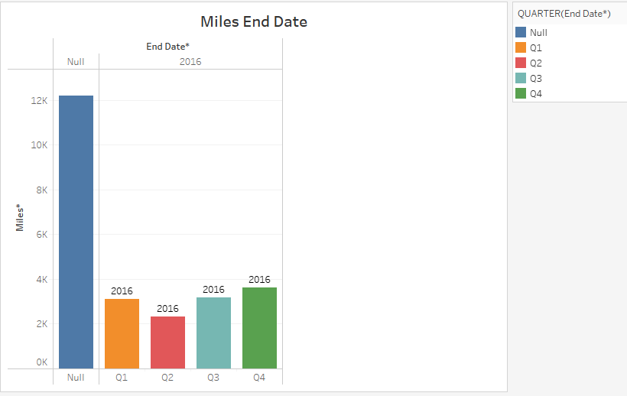

3.9 HOUR END DATE

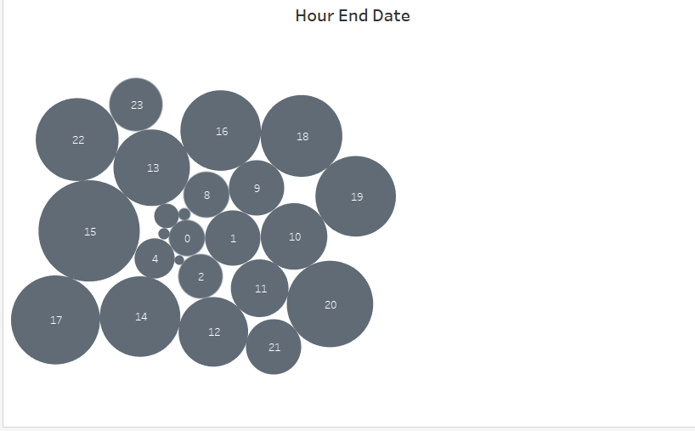

B. DASHBOARD

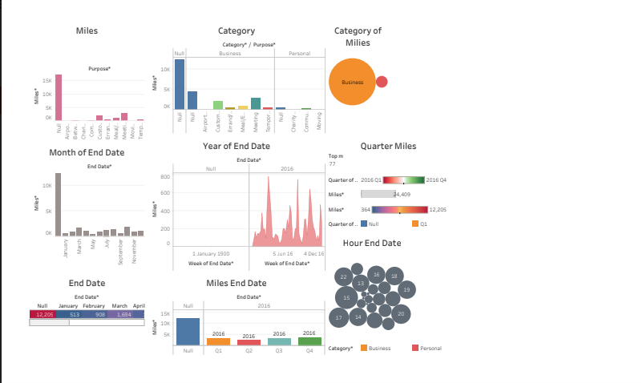

C. STORY

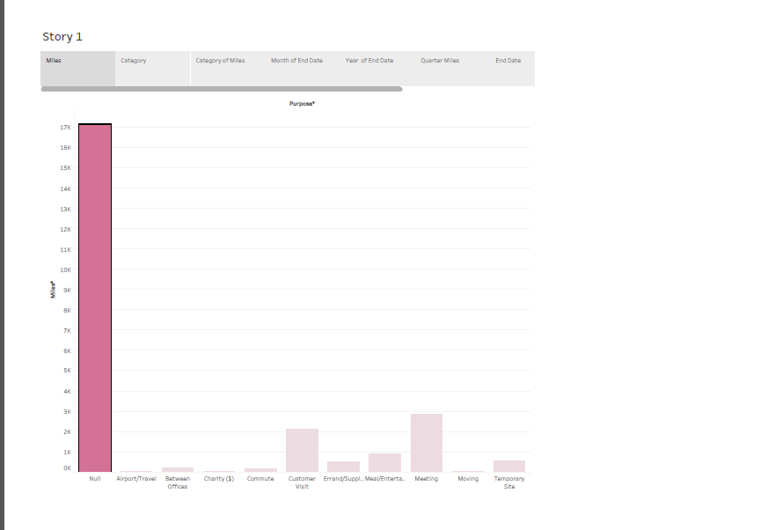

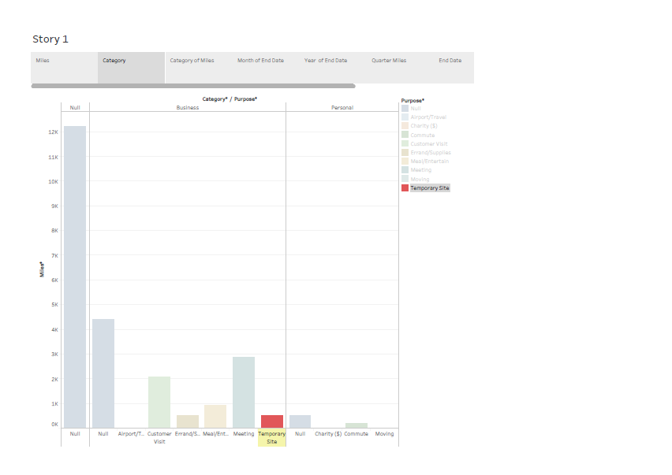

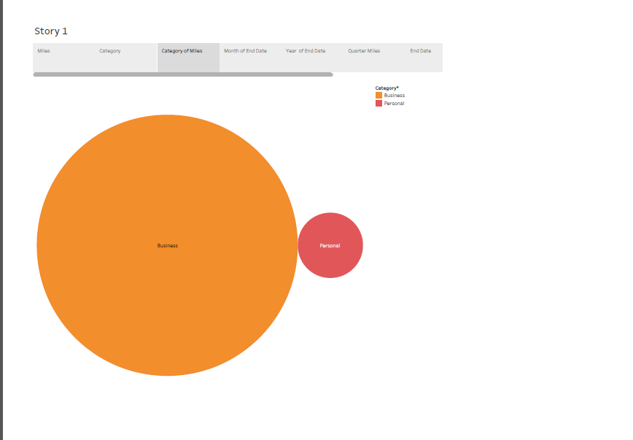

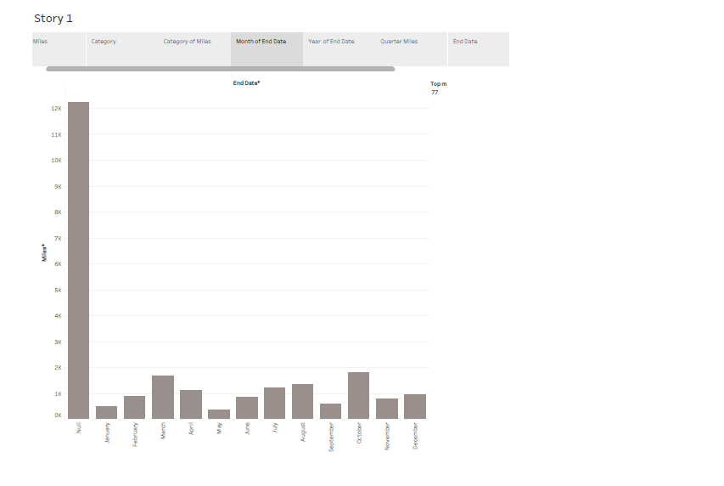

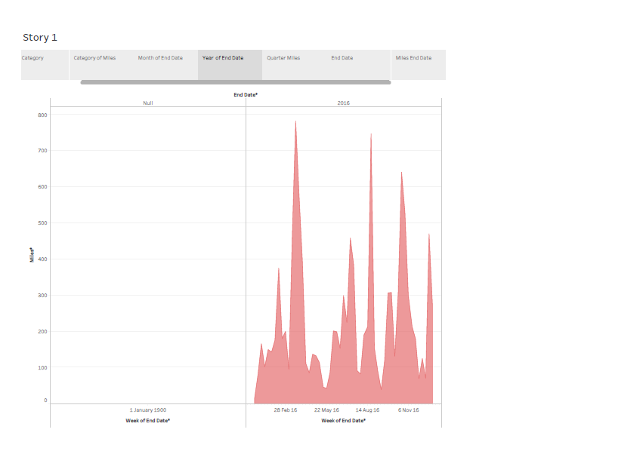

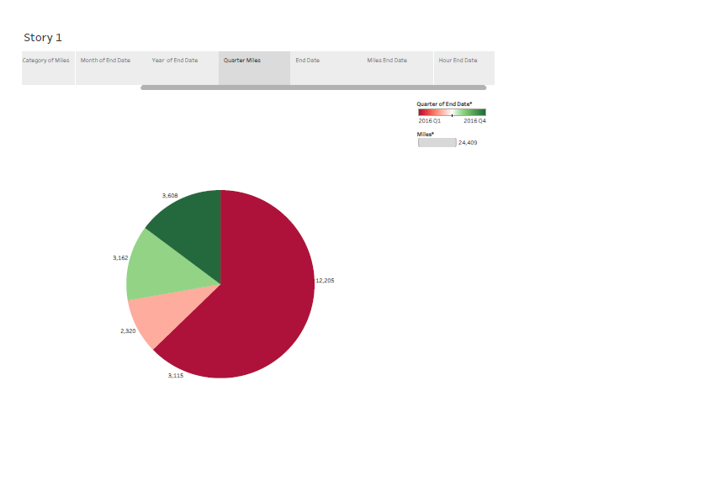

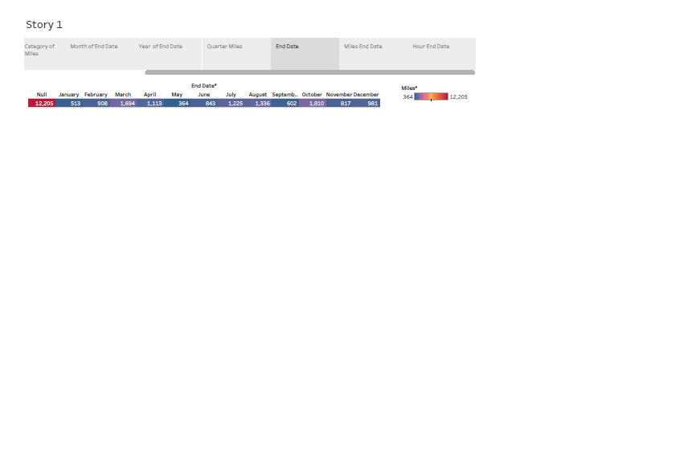

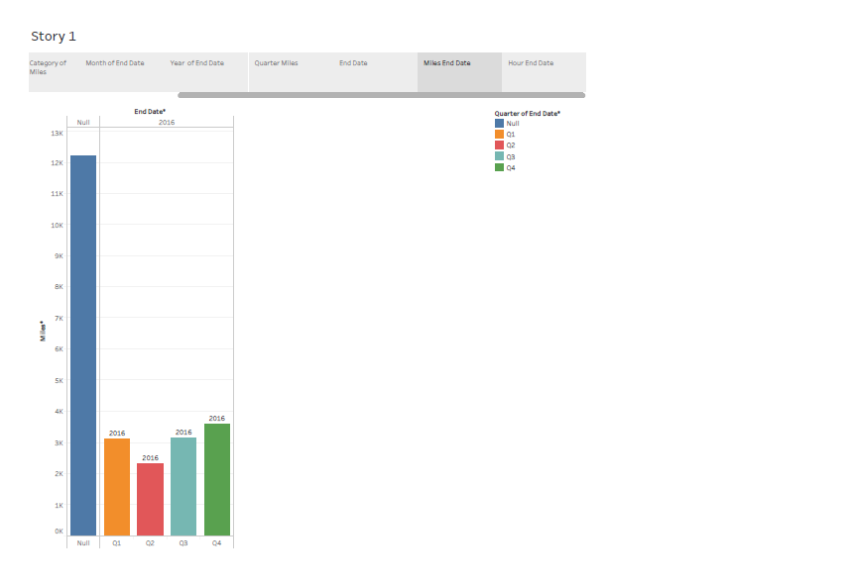

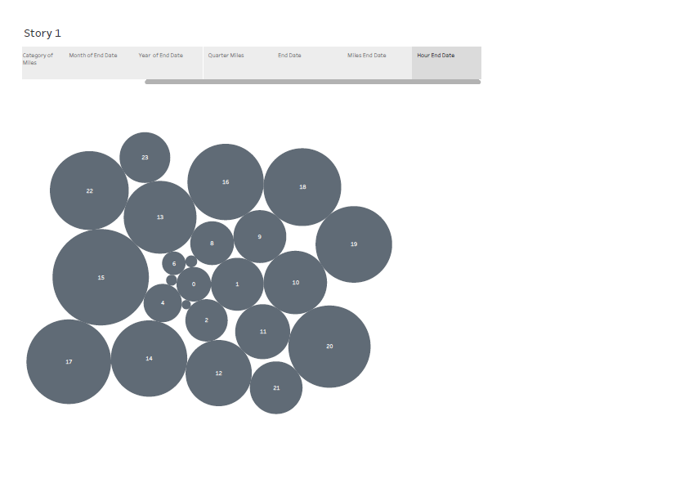

4. ADVANTAGES AND DIS ADVANTAGES

ADVANTAGES

* Convenient and Cashless

Instead of chasing a taxi on a street, or calling and waiting, app users can book a ride from any location and it arrives in minutes.

Passenger’s credit or debit card is linked to the taxi app account, no cash changes hands.

After the completion of the ride, A receipt is sent via email, and some links to options for rating and tipping the driver.

* Professional Service

Drivers for Uber may use their own cars and bike. Drivers get incentives to keep their taxis clean and well-maintained.

The cheapest options for taxis are late-model compact cars and bikes.

The riders need to insert their destinations into the app, and the drivers use the taxi app navigational features to reach the rider which is provided by the taxi app development company.

The driver talks in a polite and well-spoken manner. Drivers don't get your destination details before picking you up.

A driver with a low rating will force a driver out of Uber or its competitors.

* Competitive Pricing

Uber is less expensive than other taxi services, but not always. Longer trips are always cheaper by Uber but short rides can be expensive.

The price model for Uber and other taxi apps can have higher booking prices due to busy times of the day.

It is impossible to come up with a fixed price for an uber ride. Its costing plans vary from one city to another and from one country to another.

But uber always show you the estimated fare before starting the ride.

* Safer and Flexible

Safety is crucial for both passengers and drivers. This is what Uber is good at it. It is one of the major advantages of Uber.

The riders are registered their identities and their payment channels. Cashless transactions also make it safer, a driver and rider don’t need to carry cash.

DISADVANTAGES

* **Surge Pricing**

“Surge pricing” or “rush time pricing” is not fixed in uber. It’s a free market principle of raising prices according to supply and demand.

This means how many taxis are available (supply) and how many customers want to ride(demand).

This automated system sometimes shows differences in pricing between any two same points.

At peak times, the price could be double or more. This means too costly during rush hour.

Although this benefits uber by increasing the supply of drivers. Drivers can be motivated to earn at this time.

* **Low Fares WorryDrivers**

Some Uber drivers say they struggle to earn minimum wage. Drivers have to pay the cost of fuel, maintenance, and repairs from their own pocket.

With competition from other taxi apps, the earnings of drivers can be driven downward.

This indicates that they need to work for longer hours to earn a certain income.

* **Price Competition**

Uber and other taxi-hailing companies are engaged in an intensive fight to provide the most affordable service.

They are competing with traditional taxi services for both customers and drivers. This has led to low earnings for taxi drivers.

5. APPLICATION

1. The Uber taxi app is a representative business model in the sharing economy. The system is attractive in the market because it allows users to move more conveniently. As such, both tourists and local residents have widely used the transportation system. According to Insider [1], the market share of Uber taxis was approximately 80 percent in the second quarter in 2018. Statista [2] also reported that the market share of Uber taxis in July 2021 was approximately 75 percent in the US. Both statistics indicate that Uber could become a representative ride-hailing company; the follower Lyft showed rapid growth in the market because its market share grew by about 25 percent within 3 years [2]. This implies that competition for the taxi mobile application system has intensified. Under market conditions, it is worthwhile to first determine user characteristics to outperform in the market. The technology acceptance model (TAM) is the main theoretical framework of this research. TAM notes the association between usefulness, ease of use, attitude, and intention to use [3–5]. Numerous scholars have chosen TAM as a theoretical underpinning to test the utility of various technologies and scrutinize the link between ease of use, usefulness, attitude, and intention to use a certain technology [3–10]. Nevertheless, few studies have been conducted to ensure the explanatory power of TAM by selecting Uber taxi applications as research subjects. Although Min et al. [11] demonstrated the accountability of TAM in the area of the Uber taxi business, a single empirical study might be insufficient to understand user characteristics. Moreover, TAM could be varied depending on antecedents, and it helps to understand Uber taxi service users more deeply. However, it has been insufficiently explored in the area of Uber taxi application research. To fill these voids, this study adopts TAM as a theoretical foundation to inspect the psychological mechanism of Uber taxi application users.
2. Theoretical Foundation and Research Hypotheses

The information asymmetric condition is a theoretical underpinning of this work. Scholars contends that information asymmetry increases the likelihood of adverse selection [19,20]. Therefore, offering information to consumers is an essential element to minimize the risk in consumption [21,22]. The main function of the taxi application system is to provide information to potential customers. Service products are intangible; the customers’ main concern is ambiguity because they cannot assess the product without experience [12,13,23]. To minimize such a concern, information could become a solution because it assists customers in imagining and anticipating the service features [13,24,25]. Indeed, prior works argued that the main function of taxi service applications is to offer information: time, price, and service provider [15,18,26]. Previous studies have documented the details of information from the Uber application system. First, scholars have found that taxi application systems offer time information, including duration and waiting [14,27]. Time information allows customers to save resources because time is a resource [14,28]. Second, the extant literature states that price information is the second piece in the taxi application system because price information makes taxi service customers decrease the likelihood of over-payment [16,17,29]. Finally, prior research has noted that driver information contributes to the utility of customers using a review system that provides information about drivers [15,30]. Specifically, customers can minimize service failure risk using review information, and drivers can become kinder by the evaluation rating system [16,27,30]. In sum, the information reduces the risk to prospective service customers and saves their resources (e.g., time and money), which results in the creation of more utility. Based on the literature review, this study proposes the following research hypotheses

1. Method

Research Model and Data Collection illustrates our research model. Seven attributes (time, price, driver, ease of use, usefulness, attitude, and intention to use) appeared in the research model. The determinants of usefulness are time, price, driver, and ease of use. The antecedents of attitudes include usefulness and ease of use, and the intention to use is influenced by usefulness and attitude. All the directions were positive

1. Results of Data Analysis

Demographic Information Table 2 presents the respondents’ demographic information. There were 243 males and 169 females. Those in their 20s and 30s accounted for approximately 70 percent of the participants. Table 2 also describes the information of the living area (rural: 73, suburban: 160, and urban: 179), monthly household income (less than $2000: 85, $2000–3999: 119, $4000–5999: 88; $6000–7999: 73, and more than $8000: 47), and weekly usage frequency (less than 1 time: 145, 1–2 times: 150, 3–5 times: 74, and more than 5 times: 43).

1. Discussion

This study evaluated whether TAM is applicable for explaining the behavior of Uber mobile application users. Using usefulness as an endogenous variable, it could be inferred that time information, driver information, and ease of use allowed Uber taxi application users to attain more utility, which could be related to the individual’s working efficiency. Regarding the browsing magnitude, Uber taxi application users viewed ease of use as the most important element for their usefulness, and driver information appeared as the second most important attribute. However, price information was identified as a non-significant element to account for its usefulness. It could be assumed that application users might take price information for granted in the taxi service application system. This means that offering price information may be insufficient to create merits from the perspective of users

1. FUTURE SCOPE

The current world is witnessing many advancements and a lot of startups are evolving rigorously in the world for the past few years. All because of the emergence of on-demand ideas in the current business world with a lot of opportunities. The on-demand apps assist you to order or book anything from anywhere.

The on-demand business also aids many [startups to earn more profits](https://www.mindxmaster.com/top-5-ways-to-start-the-engineering-startup-and-get-good-profit-quickly/). Even more traditional businesses have adopted on-demand business to increase their profits tremendously.

With this spark, some of the creative-minded startups have focused their vision on the on-demand business. If you are the one having any on-demand business idea on your mind and want to reach your target audience like Uber,  then this might be the perfect blog to understand the future scope and demands of the [on-demand business](https://www.mindxmaster.com/why-business-owners-invest-in-on-demand-mobile-apps/),

Let us get into the post to know more about the Uber-like on-demand business

## ****rending ideas and demands for the on-demand industry****

Through the digital medium, it is much better and becomes easy to connect with the people in all the aspects. In the on-demand industry, there are abundant choices to choose from.

It plays a [major role in our day to day life](https://www.mindxmaster.com/how-to-handle-major-life-changes/). Business on such demand will help you to reach greater heights and also fulfill the customer needs.

## ****Scope of Uber-like on-demand startups****

As we all know, the on-demand business has been well developed and it is brimming very well. Within a few years, the on-demand industry is getting more attention due to its quickest growth rate. and the growth of the on-demand industry reaches tremendous speed in this trending world.

## ****Future possibilities****

The on-demand industry is expected to grow with the four following prior values, including speed, comfort, perfection, and quality in what they deliver. As well as, the growth of the on-demand industry provides numerous benefits for startups.

The benefits of the on-demand industry are highly efficient and also helps in scaling the business to greater heights. It has come up with many awesome features that will help you to attain your [on-demand goal](https://www.mindxmaster.com/5-important-things-to-consider-while-developing-a-last-mile-delivery-app/)and also provide you some unique experience that meets all your requirements.

Hence, many startups are interested in expanding their business using on-demand ideas. So, we can expect a bright future for the on-demand industry.

## ****Reason for the success****

With no time to wait, the on-demand services serve as the best choice and have become the perfect solution in this modern world to get exactly what they want.  Hence, there are many other several factors that are responsible for the growth and development of the on-demand industry.

Here are some of the prominent reasons for the success and growth of the on-demand industry,

* Advancements in technologies
* Gaining competitive advantage
* Providing a unique experience
* Easy availability and use
* More choices for business space
* Flexibility and affordability

## ****Find your unique space in the on-demand industry****

For any startups who want to start their [business journey, the on-demand business has become one of the favorite choices for all the startups](https://www.mindxmaster.com/tech-tips-to-know-for-your-startup-business-this-year/). As well, the on-demand business has a bright scope in the future. Hence, every [startup is ready to start their own business](https://www.mindxmaster.com/free-tools-you-can-use-for-your-new-startup-business/) and invest their money in an on-demand industry.

Moreover, most of the businesses are taking advantage of the possibilities and benefits offered by the on-demand industry to thrive in today’s competitive world.

So, it’s your time to find the space in the fast-evolving on-demand industry with the following process,

## ****Choose your niche****

The most important thing is to identify the business niche that suits your exact needs.  After finalizing the niche, the next step will be identifying the unique selling proposition of the business and collecting ideas according to the market trends before starting your own business.

Furthermore, it is essential to identify your target customers and be clear about their expectations to deal with the competition in the current on-demand industry that helps in bringing high value to your business.

## ****Build your trendy App****

Everything you need is a mobile app to attract and engage the customer in your industry. Building an efficient [on demand app](https://www.rentallscript.com/uber-clone/) is one of the prior ingredients for your business success.

[Build your own mobile app](https://www.mindxmaster.com/how-to-build-a-mobile-app-guide-for-business-owners/) with the latest trends, easy-to-use options, feature-rich, and well-designed apps. The simplicity of the mobile app interface helps you to stand apart from other competitors in the market.

## ****Focus on your customer expectations****

The next important stride in the on-demand industry is to focus mainly on [customer expectations that help in making a profitable business](https://www.mindxmaster.com/easy-ways-to-improve-customer-experience-at-your-business/). In general, customers do not want to wait for long to get the product or service whether they ordered or booked.

Providing speed and convenience in the on-demand app helps in reducing the gap between the time that the order has been placed. Hence, speed and convenience become two prior factors in determining the success of your on-demand business.

Are you ready to attract, engage, and convert customers to your on-demand platforms? Then, find your unique space and start your own on-demand business with unique plans, strategies, and ideas.

1. CONCLUSION

I hope this article is useful for every on-demand startup. It also helps in fulfilling each and every need of the customer with whatever they need will be available at a single tap. Also, it provides a great opportunity for startups to go with such an innovative idea.

By seeing the above predictions and reason behind the success of the on-demand business, we came to conclude that it should be the way of the future.

So, startups are using this trend to succeed in their own [on-demand business](https://www.mindxmaster.com/tips-investing-as-small-business-owner/) ambition. Starting an on-demand business is completely viable and surely benefits from all the aspects.

If you want to succeed and earn more profit in on-demand business, then this is the right time for you.